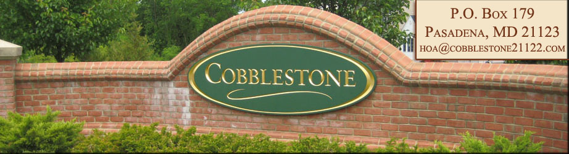

ARCHITECTURAL REVIEW COMMITTEE SUBMISSION FORM

Any modifications to your property must be submitted to the Architectural Review Committee for approval PRIOR to any work or modifications being constructed on your property. Please allow up to 45 days to complete processing. Include complete descriptions, dimension, style, type drawings, materials being used, colors, etc. The more information you can provide will help to expedite your application.

Date Submitted __________________ Phone # ________________________ Lot # ____________
Property Owner ______________________________ E-mail: _______________________________

Property Address_________________________________ City _________________ Zip _________

Contractor_______________________ Phone #___________________ Fax # ________________

ITEMS FOR REVIEW
 | Landscaping |  |  | Fence
 | Exterior Finishes |  |  | Deck
 | Lamp Post |  |  | Patio
 | Mailbox |  |  | Improvements
 | Driveway |  |  | Sheds
 | Sidewalk |  |  | Swimming Pools
Other:

Homeowner Comments – Remember to attach with the Architectural Review Committee Submission Form the following. Pictures or diagrams, including complete descriptions, dimension, style, specific material list, color samples, finishes, and other design elements.

Homeowner is responsible for compliance with all applicable county ordinances and permits if application is approved.

FOR OFFICE USE ONLY
Date Received | Date Approved | Date Denied
Date of Letter | Date of Signature | Date Mailed

Return to:
Cobblestone Property Owners Association, P.O. Box 179, Pasadena, MD 21123

HOA@COBBLESTONE21122.com

